Ucom CJSC
Procurement of AVR, for “Sayat-Nova” Data Center

RFQ

Yerevan, 27.04.2022

Request for Quotations (RFQ)
republic of Armenia
Ucom CJSC, Procurement of AVR for “Sayat-Nova” Data Center
RFQ No: TS-AG-22-3

General Conditions

Introduction

Ucom CJSC is a broadband service provider with licenses for voice, international gateway, and Internet services.

This document comprises Ucom CJSC and appears as a Request for Quotations (RFQ) for the Procurement of the following Goods:

Electrical introductory switchgear 1600A with ATS

This RFP has been issued to obtain all needed services and technical requirements.

Requirements

The successful bidder is expected to supply customized equipment described in the technical requirements.

All equipment proposed by The Supplier shall be dimensioned in accordance with the technical specifications. The Bidder may substitute alternative solutions, provided that it demonstrates to the Purchaser’s satisfaction that the use of the substitute(s) will result in the System being able to perform substantially equivalent to or better than that specified in the Technical Requirements.

All equipment supported by the Supplier should be newly manufactured.

The Supplier shall ship the equipment based on the following delivery terms: INCOTERMS DAP Yerevan, Armenia.

Hardware Delivery period: 65-90 Days.

The Supplier shall provide the supporting documentation, including user manuals in the English/Russian language, for its equipment and training/certification of 2 company relevant employees.

The Supplier shall provide factory warranty, 3 years, starting from the date of signed Final Acceptance Certificate.

Technical conditions, Installation and Administration

Requirements are described in the below supporting technical specifications.

Other requirements

By submission of documentary evidence in its proposal, the Bidder must establish to the Purchaser’s satisfaction:

that, in the case of a Bidder offering to supply key goods, that the Bidder does not itself produce, the Bidder is duly authorized by the producer to supply those components in the Purchaser’s country under the Contract(s) that may result from this bidding. This will be accomplished by including the Manufacturer’s/Distributor’s Authorization(s) in the proposal /appendix 2/.

that, if a Bidder proposes Subcontractors for key services these Subcontractors have agreed in writing to serve for the Bidder under the Contract(s) that may result from this bidding.

Price quotation – price quotation should be prepared using form of appendix 1 specifying words and figure, as well as the various amounts and the respective currencies. The compression will be done based on Incoterms DAP Yerevan, Armenia.

Authorized representatives of the eligible bidder shall be entitled to request clarifications regarding all of the RFQ documents by submitting requests by email to: Mr. Hovak Podosyan (hovak.podosyan@ucom.am) and Mr. Arthur Soghomonyan (arthur.soghomonyan@ucom.am).

At any time prior to the deadline for submission of proposals, Ucom may, for any reason, whether at its own initiative or in response to a clarification requested by a prospective Bidder, amend the RFQ or cancel the RFQ process. The request for clarification and the response shall be in writing.

The Supplier shall bear all its cost for the tendering and RFP process. Ucom shall under no circumstance be liable for any cost for Supplier’s tendering process, regardless of whether or not the Supplier is selected.

The proposal prepared by the Bidder and all correspondence and documents related to the proposal exchanged by the Bidder and Ucom shall be written in English, all data, documents, descriptions, instructions submitted by the Bidder and all communication between the Parties shall be in the English Language.

The Bidders shall submit their proposals electronically to Mr Hovak Podosyan (hovak.podosyan@ucom.am ) and Mr. Arthur Soghomonyan (arthur.soghomonyan@ucom.am), not later than May 16 of 2022 year, 18:00 (Local time), and the letter should be clearly marked RFP NO: TS-AG-22-3. Later bids may be rejected by the Purchaser.

Proposals shall remain valid, at a minimum of 120 days after the deadline date for proposal submission prescribed by the Purchaser. A proposal valid for a shorter period may be rejected by the Purchaser as non-responsive.

For evaluation and comparison purposes, the Purchaser shall convert all proposal prices expressed in various currencies and amounts into a single currency AMD, using the selling exchange rate established by the Central Bank of Armenia on the Proposals opening date.

This RFQ and other related documents (as well as the communication) included are strictly confidential, the “Receiving Party” shall keep confidential and shall not, divulge to any third party any documents, data, or other information. Failure of the Bidder to comply with the request may result in the rejection of its Proposal and further cooperation.

Notwithstanding the above point, the Receiver may furnish Confidential Information of this RFP: (i) to its support service suppliers and their subcontractors and its subcontractor to the extent reasonably required for them to perform their work under their contracts; in which event the Receiving Party shall ensure that the person to whom it furnishes Confidential Information of the Disclosing Party is aware of and abides by the Receiving Party’s obligations under this point as if that person were party to the Contract in place of the Receiving Party.

The Purchaser shall award the Contract to the Bidder whose bid has been determined to be the lowest evaluated bid and is substantially responsive to the bidding documents, provided further that the Bidder is determined to be qualified to perform the Contract satisfactorily. Other Contract points shall remain negotiable between the parties.

Technical specifications
In Russian
Тех. требование электрощита ВРУ 1600А с АВР

Режим работы контролера четырех входoвого АВР
- Полностю отключенный АВР
- Ручной режим управления АВР
- Полный автоматический режим работы с двумя вводами 0,4кв и ДГУ1
- Полный автоматический режим работы с двумя вводами 0,4кв и ДГУ1 и ДГУ2
- Все режимы работы контролера и эл.механической части АВР должны поддерживаться питанием от ИБП
- Перключатель режимов работы АВР механический с четыримя положениями.
Переменные прошивки контролера
i1 - количество флуктуаций эл.питания
i2 - количество продолжительного перехода на батареи
T1 - время для измерения флуктуаций
T2 - время для перхода в исходный режим
T3 – задежка времени отсутсвия эл.питания (совместно с сигналом i2)
T4 – время задежки для подзарядки батарей ИБП платформы
N – колличество переходов процессов
TД1 – время наработки ДГУ1 или ДГУ2

- Алгоритм работы АВР совместно с ДГУ1, ДГУ2 и городским с двумя вводами эл. питанием
Режим работы - исходное состояние PLC АВР – аварийное срабатывание АВР при пропаже одного или двух вводов городской эл. сети 0.4кв
Для интеграции и синхронизации работы АВР и ИБП платформы необходимо дополнительно добавить в прошивку алгоритма АВР входные 2 порта в PLC для сигнализации срабатывания вводов (при переходе на батареи ИБП 1 или ИБП 2 на более 30 сек) должны произходить переключения нагрузки по «вводу 1» или «вводу 2» или наоборот , а при срабатывание тревог (при переходе на батареи ИБП 1 или ИБП 2 на более 30 сек) на обоих вводах, срабатывает переход на шины ДГУ1 или на ДГУ2 и обратно при восстановлении вводов 1 или 2. Нормальный режим работы подразумевает питание распределенное по ровну нагрузки от ввода 1 и 2 ( 50/50%) . Исходный, начальный режим работы АВР – эл. Питание 0.4кв поступает от ввода 1 и ввода 2, секционный автомат не активен, команды для старта ДГУ 1 и ДГУ2 не активены.
Режим работы PLC АВР:
Поведение алгоритма PLC АВР при краковременных флуктуациях эл. сети 0.4кв.
При появлении сигнала переход на батареи ИБП 1 или ИБП2 по вводу 1 или вводу 2 в PLC регистрируется количество флуктуаций эл. питания в переменной «i1» за время перменной “T1”. При превышении заданного количества «i1» необходимо осуществить переход в режим работы от ДГУ1 или ДГУ2 через моторизированный секционник на установленное время переменной “T2”. По истечении времени переменной “T2” осуществляется переход в исходный режим при наличии качественного* эл.питания АВР на вводе 1 или вводе 2. В случае продолжающейся сигнализации срабатывание тревог ИБП 1 или ИБП2 по вводу 1 (переход на батареи)» в количестве переменной «i2» раз в течении времени переменной “T3” происходит повторный переход на работу от ДГУ1 или ДГУ2 через секционник на установленное время переменной “T2”. Такой цикл перехода с 1 или 2 ввода на ДГУ1 или ДГУ2 через секционник при повторяющихся инцидентах флуктуаци на вводе 1 и при перходе на батареи ИБП 1 или ИБП2 необходимо продолжать процесс «N» колличество раз. При превышении «N» заданного числа переходим на время “T3” и сбросиваем «N» и “T3”. Питание датацентра при этом остается в режиме ДГУ 1 или ДГУ2 . В случае отсутствия повторяющихся инцидентов по питанию по вводе 1 или на вводе 2 (нет перехода на ИБП1 или ИБП2 на батареи) АВР переходит в исходное состояние( пункт 1) . В случае неудачного запуска или случайной остановки ДГУ1 или ДГУ2 необходимо запустить не октивный ДГУ , отключить моторизированный автомат активного ДГУ и включить моторизированный автомат запускаемого ДГУ игнарируя время наработки последнего “TД1”. Далее, происходит продолжение работы ДГУ платформы в режиме интервала времени T3, в котором произошел неудачный запуск или внезапная остановка одного из ДГУ.
Приборы и сигналные лампочки на палеле шита
По стандарту компании Ucom по строительсву датацентров , все электронные компоненты АВР/ВРУ должны быть от компании «ABB» или «Шнайдер электрик» и должны иметь Ethernet вход для удаленного мониторинга/контроля
- На каждой двери вводов должны быть установлены сигнальные индикаторы состояния трех фаз.
- Прибор универ.цифр.изм. с Ethernet для каждого входа на каждой двери ввода
- Контроллер АВР с Ethernet входами
- На двери шкафа контрелера должны быть установлены кнопи для режима ручного управления АВР с надписями «Пуск» и «Стоп» с световым индикацией исполнения команды. Дополнительные функциональные надписи над и под кнопками приветсвуются.
- Каждый ввод из двух городских должен быть оснащен двутарифным эл. счетчиком потребления эл. энергии.
- Раzмеры шкафов не должно превишать указанных пределов:
Глубина – 600 - 650 мм
Ширина – 600 – 850 мм
Высота – 2000 – 2100 мм
Тип всех шкафов наполные с цоколем без бокавых заглушек

На основании данного технического требования разрабатывается алгоритм работы схемы управления системы АВР ВРУ. Окончательная проверка работы АВР в соответствие с заданным алгоритмом производится на монтажном участке завода-изготовителя после изготовления щита ВРУ. При необходимости, окончательная настройка алгоритма работы в соответствие с особенностями технологического процесса эксплуатации ВРУ производится на объекте заказчика с выездом специалиста.

Структурное строение компонентов всех шкафов АВР
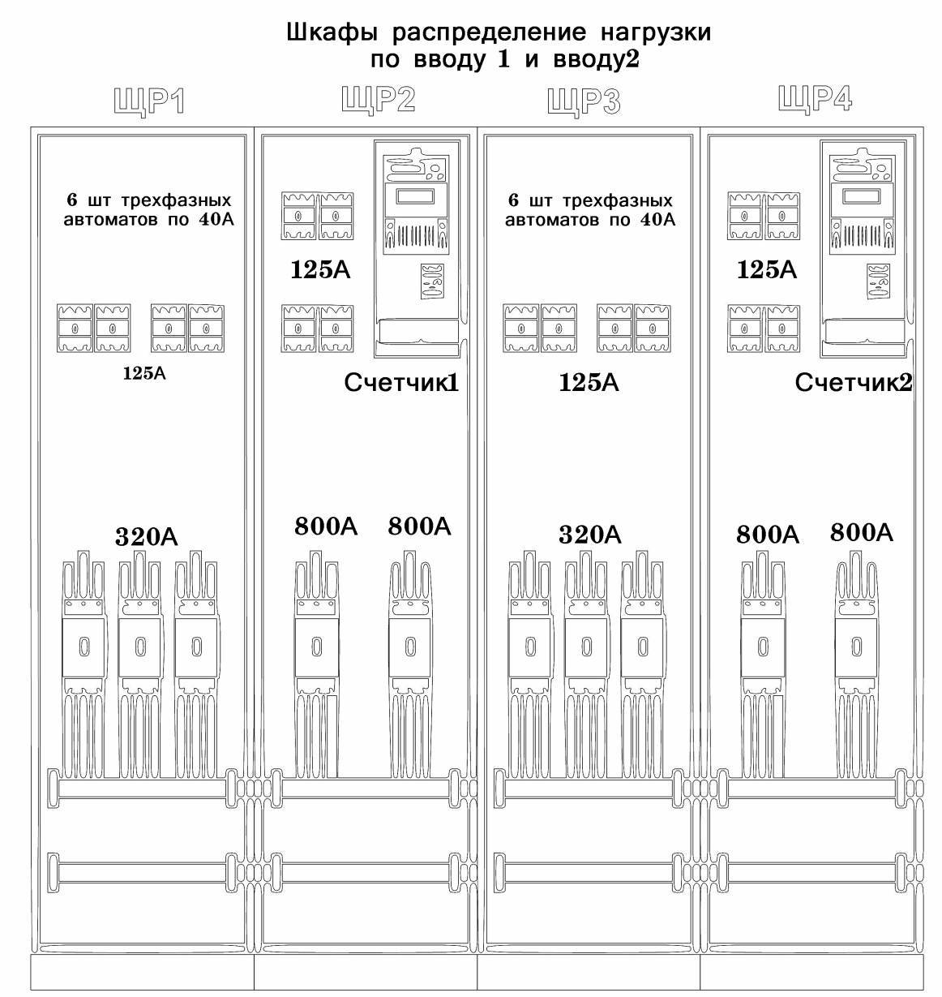
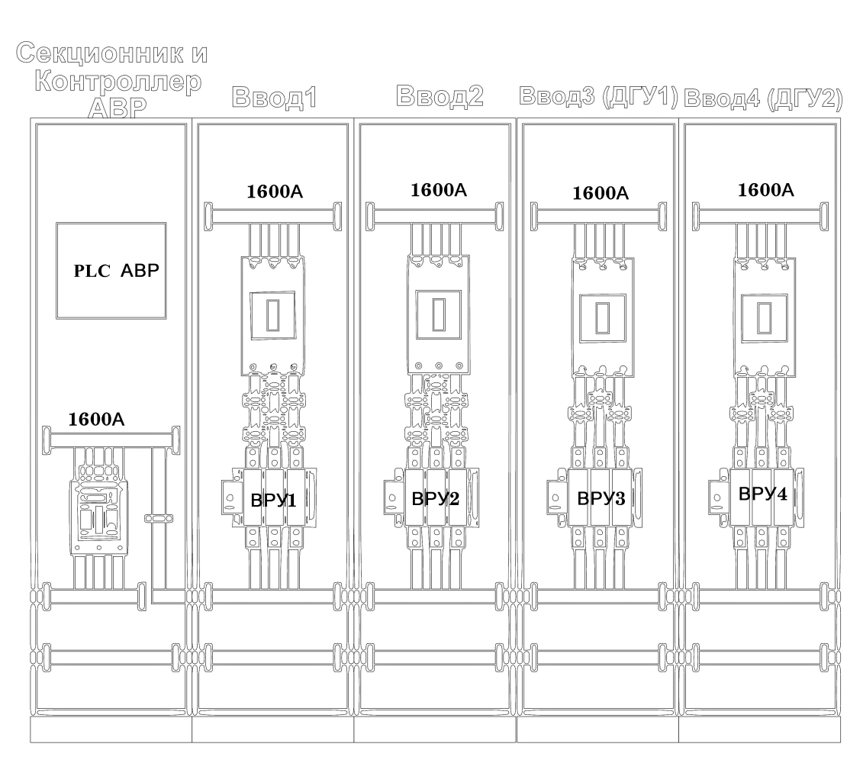
In Russian
In English
Technical requirementс for the electrical introductory switchgear 1600A with ATS

Operating mode of the PLC controller of four input ATS
1. Completely disabled ATS
2. Manual control mode of ATS
3. Full automatic operation with two inputs 0.4kv and DGU1
4. Full automatic operation with two inputs 0.4kv and DGU1 and DGU2
5. All modes of operation of the controller and the electrical and mechanical part of the ATS must be supported by power from the UPS
6. Mechanical ATS operation mode switch with four positions.

Variables for PLC firmware
I1 - the number of fluctuations of AC power
i2 - the number of prolonged UPS battery transition
T1 - time to measure fluctuations
T2 - time for playback to the original mode
T3 - the lack of an abnormal power time (together with the I2 signal)
T4 - Scheduled time to recharging batteries UPS platform
N - the number of transitions and processes
TD1 - working time DGU1 and DGU2

- ALGORITHM of work ATS TOGETHER with DGU1, DGU2 and City two AC POWER inputs
The mode of operation is the original state of the ATS PLC - emergency response at the disappearance of one or two AC inputs of the City power 0.4kV
To integrate and sync operation of the ATS and UPS, the platforms are additionally added to the firmware of the ATS algorithm input 2 ports in the PLC to signal the triggering of inputs (when switching to the UPS 1 or UPS 2 batteries) for more than 30 seconds) should be checked for "input 1" or "Input 2" or vice versa, and when alarm is triggered (when switching to the UPS battery 1 or UPS 2 for more than 30 seconds) on both inputs, the transition to the DGU tires1 or DGU2 and back when recovering 1 or 2. Normal mode of operation implies nutrition distributed by smooth load from input 1 and 2 (50/50%). The initial, initial mode of operation of the ATS - AC. Power supply 0.4kV comes from input 1 and input 2, the sectional machine is not active, the commands for the start of DGU 1 and DGU2 are not active.

The operation of the ATS PLC :
The behavior of the ATS PLC algorithm with short-term fluctuations of City AC power 0.4kV.
When the signal appears, the transition on the batteries of the UPS 1 or UPS2 on the input 1 or input 2 in the PLC registers the number of short fluctuations. Nutrition in the "I1" variable during the permenity "T1". Upon exceeding the number of "i1", it is necessary to transfer to the operation of DGU1 or DGU2 through the motorized sectional breaker with the set time of the variable "T2". After the T2 time expires, the "T2" variable is the transition to the original mode in the presence of AC power high-quality i2 "times during the time of the variable" T3 "repeatedly go to work from DGU1 or DGU2 through the sectional breaker with the time of the variable" T2 ". Such a cycle of transition from 1 or 2 input for DGU1 or DGU2 through the sectional breaker at repeated incidents of fluctuations of AC power on entering logical 1 and at on the UPS 1 or UPS2 batteries, it is necessary to continue the process "N". Upon exceeding the "N" of the specified number, go to the time "T3" and reset "N" and "T3". The downtown of the data center remains in DGU mode 1 or DGU2. In the absence of repeated nutrition incidents on entering 1 or input 2 (no transition to UPS1 or UPS2 on the battery) ATS goes to its original state (paragraph 1). In case of unsuccessful launching or random stop of the DGU1 or DGU2, it is necessary to stop no accurate DGU, turn off the motorized automatic input breaker of the active DGU and turn on the motorized input breaker of the DGU launched ignoring the time of the last "TD1". Further, there is a continuation of the DGU platform in the time interval mode T3, in which there was an unsuccessful launch or a sudden stop of one of the DGU.

Devices and light bulbs on the ATS cabinets’ doors panel
According to the UCOM standard for the construction of the data centers, all electronic components of the ATS must be from the company "ABB" or «Schneider Electric " and must have an Ethernet input for remote monitoring / control
1. On each door of the inputs must be installed signal indicators of the status of three phases.
2. The device is university. With Ethernet for each entry on each door input
3. ABR controller with Ethernet inputs
4. Buttons must be installed on the cabinet doors for the manual control mode of the ATS with the "Start" and "Stop" labels, with a steady light indication of the execution of the command. Additional functional inscriptions above and under the buttons are welcome.
5. Each entry of two City AC inputs must be equipped with a 2-tariff Consumption counter and Energy.
6. Dimensions of cabinets should not exceed the specified limits:
Depth - 600 - 650 mm
Width - 600 - 850 mm
Height - 2000 - 2100 mm
Type of all cabinets: Floor type with a basement without cabinets spacing walls

Based on this technical requirement, the algorithm for the operation of the ATS system management scheme is being developed. The final test of the work of the ATS in accordance with the specified algorithm is made on the assembly site of the manufacturer after the manufacture of ATS. If necessary, the final configuration of the work algorithm in accordance with the peculiarities of the technological process of operation of the ATS is produced at the customer's facility with the departure of relevant specialists.

Structural components of all ATS cabinets
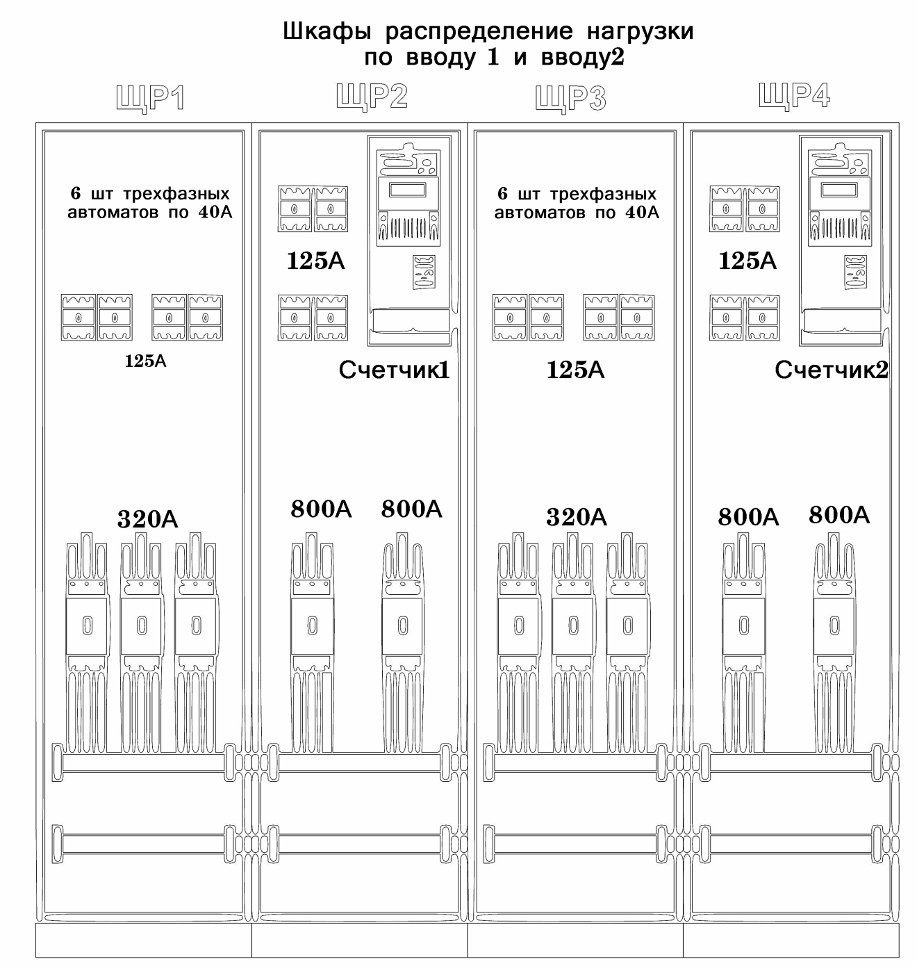
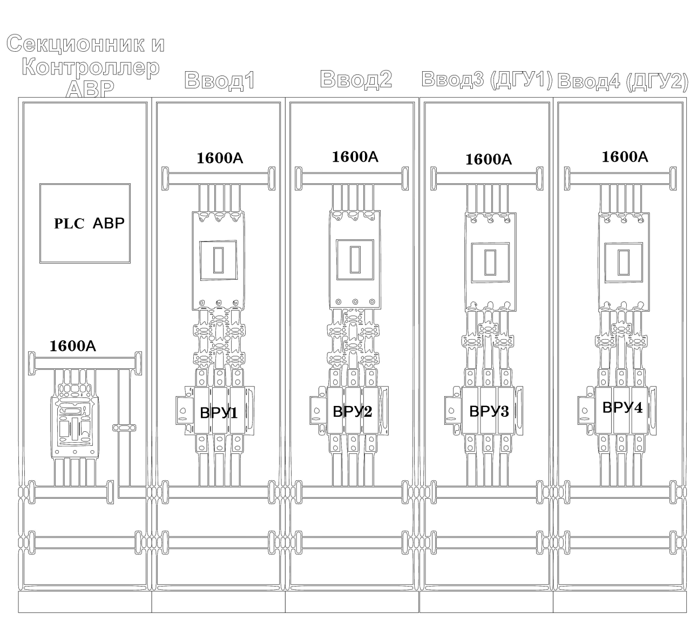

Appendix 1
Price quotation
Date of this Quotation submission: [insert date of Quotation submission]
RFQ No.: TS-AG-22-3
To: Ucom CJSC
- Conformity: We offer to supply in conformity with the bidding document and in accordance with the Delivery Schedules specified in the RFQ the following Goods: [insert a brief description of the Goods and Related Services];
- Price: The total price of our Quotation, excluding any discounts offered in item (f) below is:
Total price is: [insert the total price of the Quotation in words and figures, indicating the various amounts and the respective currencies];

- Validity: Our Proposal shall be valid 120 days, and it shall remain binding upon us and may be accepted at any time before the expiration of that period;
- Purchaser Not Bound to Accept: We understand that you are not bound to accept the lowest evaluated cost Quotation, the Most Advantageous Quotation or any other Quotation that you may receive.

Name of the Bidder: *[insert complete name of the Bidder]
Name of the person duly authorized to sign the Quotation on behalf of the Bidder: *[insert complete name of person duly authorized to sign the Quotation]
Title of the person signing the Quotation: [insert complete title of the person signing the Quotation]
Signature of the person named above: [insert signature of person whose name and capacity are shown above]
Date signed [insert date of signing] day of [insert month], [insert year]
*: Person signing the Quotation shall have the power of attorney given by the Bidder. The power of attorney shall be attached with the Price Quotation.

Appendix 2
Manufacturer’s Authorization

Date: [insert date (as day, month and year) of Quotation submission]
RFB No.: TS-AG-22-3

To: Ucom CJSC

WHEREAS
We [insert complete name of Manufacturer], who are official manufacturers of [insert type of goods manufactured], having factories at [insert full address of Manufacturer’s factories], do hereby authorize [insert complete name of Bidder] to submit a Quotation the purpose of which is to provide the following Goods, manufactured by us [insert name and or brief description of the Goods], and to subsequently negotiate and sign the Contract.

We hereby extend our full guarantee and warranty with respect to the Goods offered by the above firm.

Signed: [insert signature(s) of authorized representative(s) of the Manufacturer]

Name: [insert complete name(s) of authorized representative(s) of the Manufacturer]

Title: [insert title]

Dated on ____________ day of __________________, _______ [insert date of signing]

